**Figure List**

* **PM2.5 concentration map**
* **PM2.5 monitor map**
* **Figure 3 – convert current one to boxplots**

**Table List for Paper**

* **Table 1. Average air pollution levels for each group by urbanicity**
* **Table 2. Average air pollution exposure levels and racial isolation overall and by region**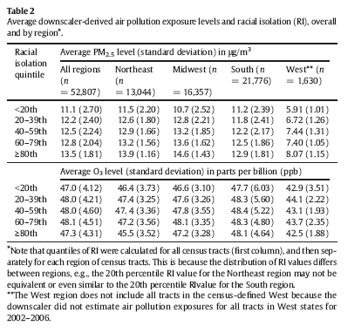
* **Average downscaler-derived air pollution levels for each population group by RI**